**Destructuring props & state:**

**Functional Component:**

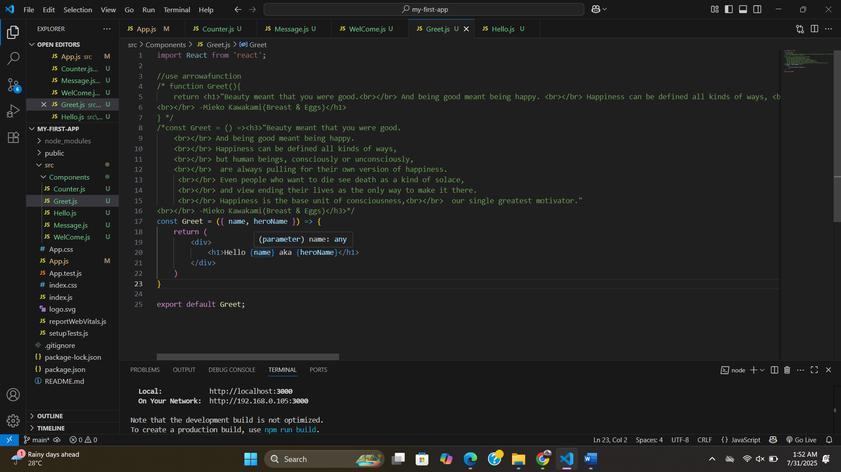

**Another way of Destructuring props & state:**

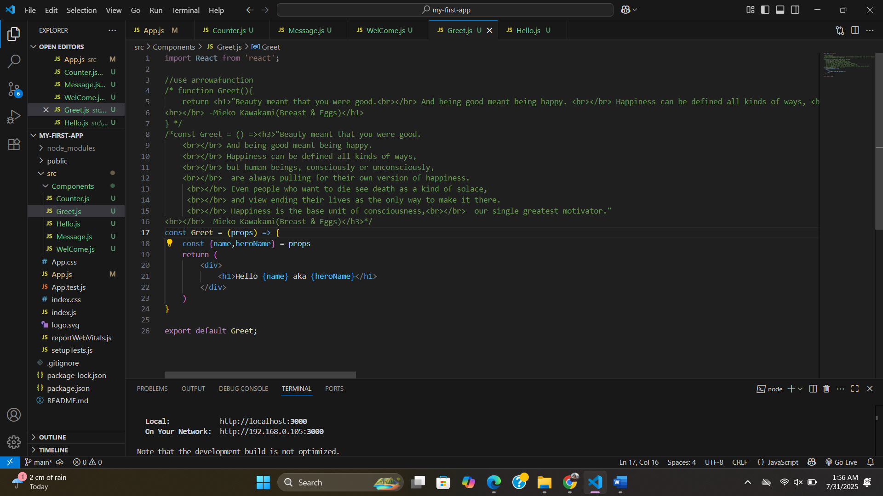

**Class Component:**

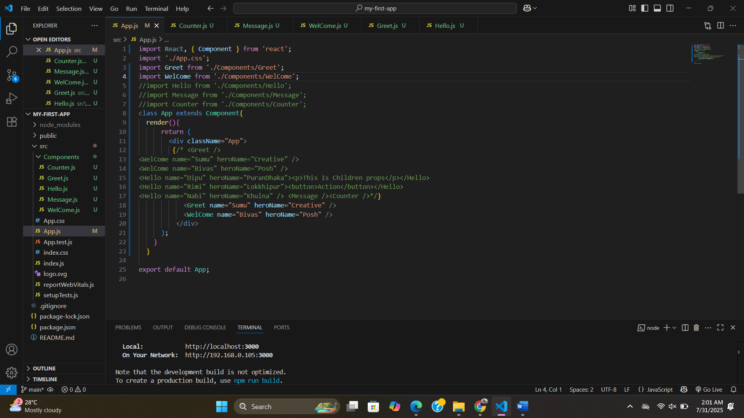

**State Component:**

